1. 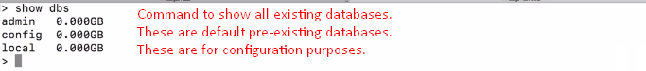 The default databases here simply exist to store **configuration** for this database server such as
   1. For example: admin database will allow you
      1. To create users and roles
      2. How people can use and interact with the databases.

**NOTE**: We will cover all this later.

1. 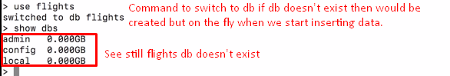
2. 